Activity

- Ron Ritchhart relates Visible Thinking and Learning to learning to dance. Why does he say this?
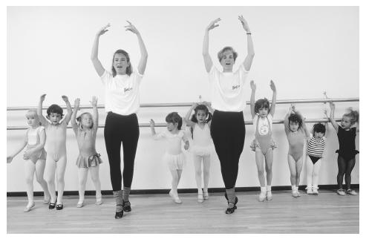

- How do teachers empower students to be life long learners?

- Name a question that can facilitate and clarify a
learners own thinking?

.

