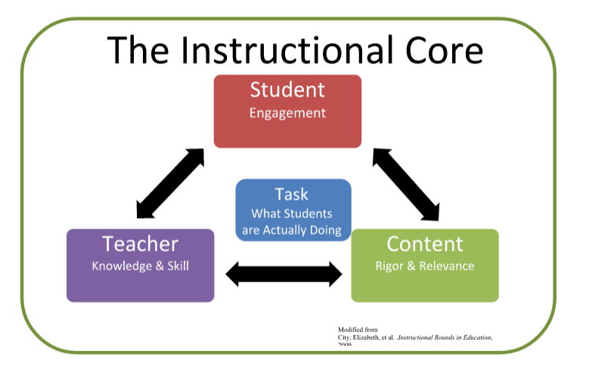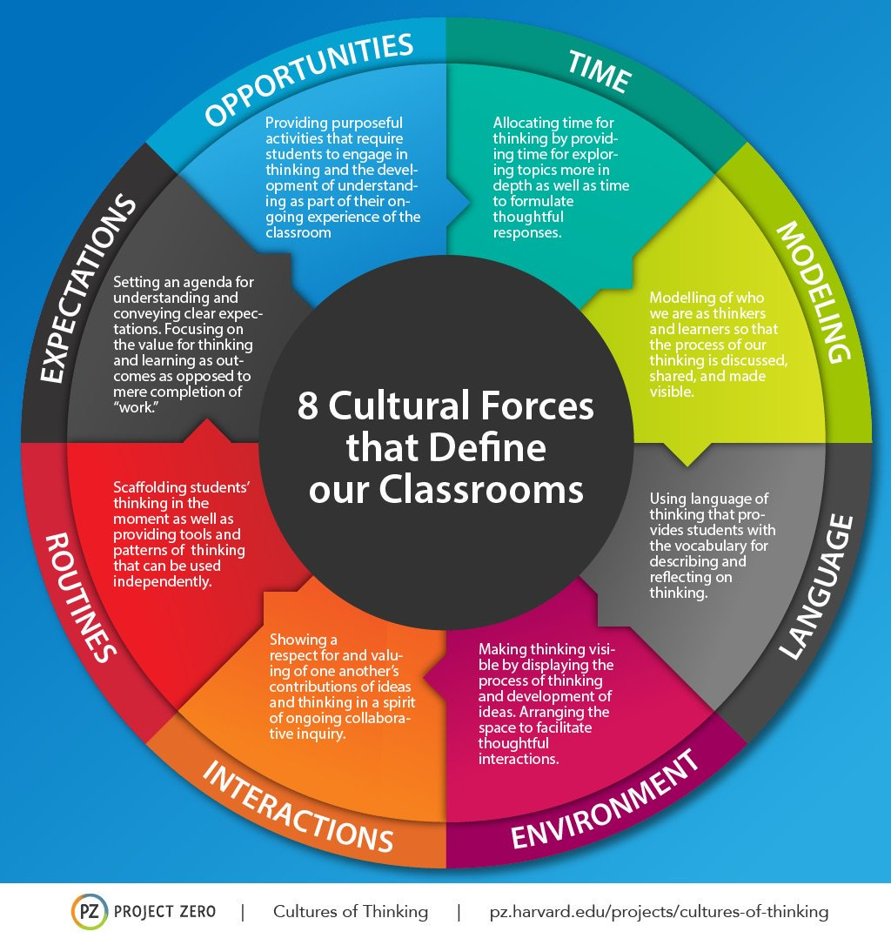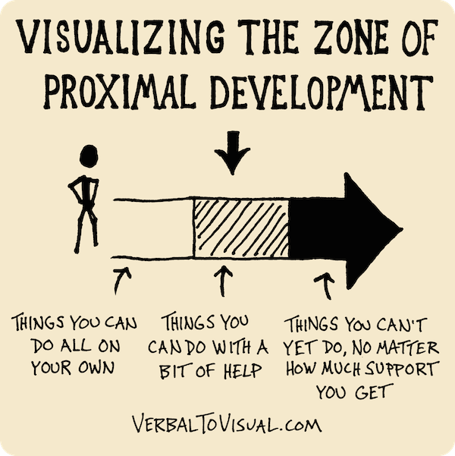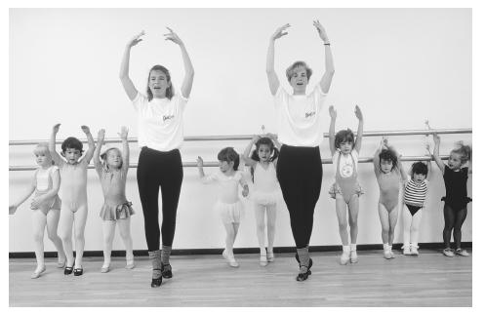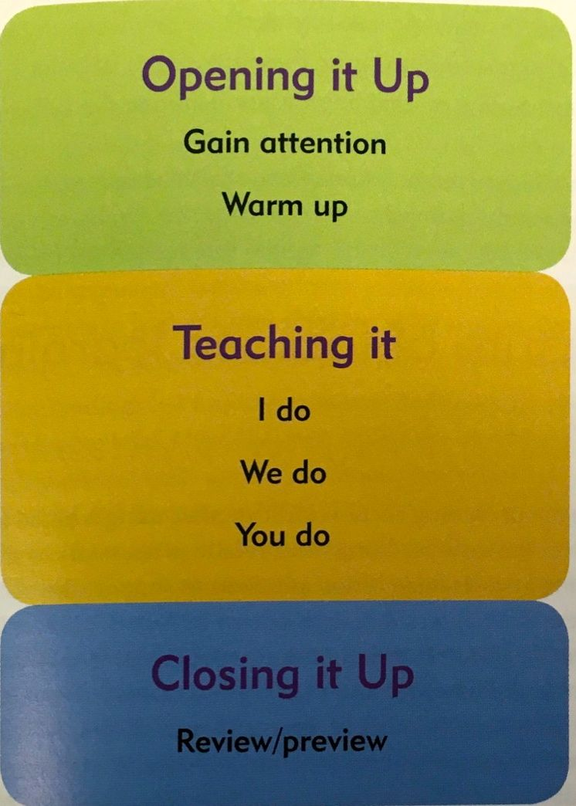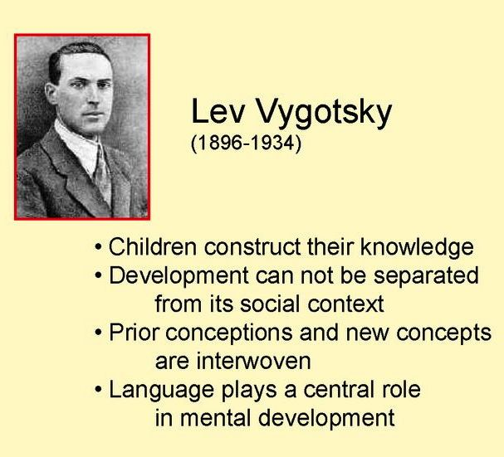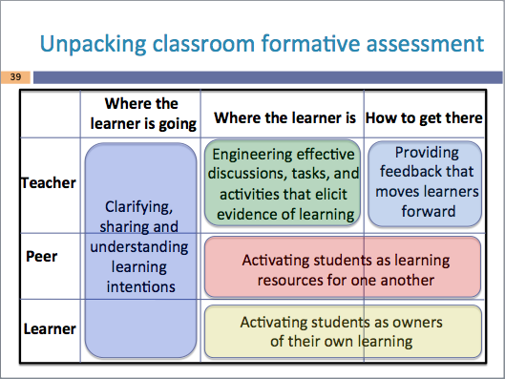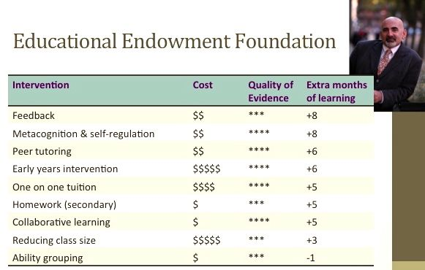

**OUR VISION**

*Granville East Public School (GEPS) leads a dynamic and innovative community, characterised by powerful partnerships, quality learning, inclusivity and excellence. The school inspires purposeful, holistic and future focused teaching and learning that engages students in their lives and their world. GEPS empowers creative and critical thinkers who experience enjoyment*

**INTRODUCTION**

We have developed this framework as a blueprint for the pedagogy that will enable us to achieve our vision. We believe that the learning progress of every student should be our priority; and that every student deserves to make at least a year’s progress in every calendar year.

Developing high-level skills in literacy and numeracy is a fundamental requirement for our students, but we also believe in a broad curriculum that prepares students for life. In the words of Hattie:

*What is the learning that we aim to impact on? The love of learning, involving students to stay in the learning and seeing the ways in which students can improve their healthy sense of being, respect for self, and respect for others as well as enhancing achievement (the whole child).*

We believe that to impact on the learning of our students we must take action in the “instructional core” (City, Elmore, Fiarman and Teitel). This highlights the fact that it is the relationship between teachers, students and the content taught, not the qualities of anyone of them by themselves, that determines learning.

This framework is about the pedagogy that we need for our students at GEPS. As such it *encompasses the performance of teaching together with the theories, beliefs, policies and controversies that inform and shape it* (Siraj & Taggart). Research consistently shows that the pedagogy that teachers use makes a significant difference to student learning outcomes (Siraj & Taggart; Hattie; Wiliam).

We hope that all teachers at our school will make regular use of our Powerful Learning Framework and use it as a vehicle for reflection, professional discussion and to inspire further learning.

**OUR GOAL**

*Wherever a student starts from on the first day of the year, he or she deserves to have made at least a year’s worth of progress by the end of it -* Goss, Hunter, Romanes & Parsonage

**MAKING A DIFFERENCE**

*Accomplishing the maximum impact on student learning depends on teams of teachers working together, with excellent leaders or coaches, agreeing on worthwhile outcomes, setting high expectations, knowing the students’ starting and desired success in learning, seeking evidence continually about their impact on all students, modifying their teaching in light of this evaluation, and joining in the success of truly making a difference to student outcomes.*

-John Hattie

**Powerful Learning Framework**

**Granville East Public School**

**THE IMPORTANCE OF ESTABLISHING THE RIGHT CLASSROOM CLIMATE AND CULTURE**

*One of the first things you, as a teacher at GEPS, should consider is how to establish and maintain the learning environment so that every child is nurtured and every child learns.*

*In this framework we highlight three main points as having key relevance for you and your students. As a low socio-economic status (SES) school establishing and maintaining high expectations for all learners is of key importance. Given the high proportion of EAL/D learners at our school, teaching language clearly and explicitly is paramount. Recognising and valuing the cultural background of students is also critical to establishing the right climate and culture.*

**1. Learning is relational and requires a culture of respect, trust and productive relationships**

Classroom relationships are established and maintained through language. These relationships must be mutually respectful and are modelled through teacher/student interactions (Edward-Groves, Anstey & Bull). Hattie also states that classroom environments must be positive and caring, promoting relational trust both between teachers and students and amongst students. Strategies such as humour and quiet reminders have been found to be effective in developing such relationships (Siraj & Taggart).

It is also important for us as teachers to take time to explore the social and emotional worlds of our students in order to nurture a climate of social supports for successful learning (Halbert, & Kaser; Vygotsky cited in Davydov). Learners need an environment where they are able to take risks and feel free to voice their opinions without being judged. Errors must be welcomed and understood as a vital part of the learning process (Wiliam). The physical environment or set-up of the classroom needs to be flexible so that it can be adapted to the need or type of interactions (Edward-Groves et al).

**2. Learning is enhanced by allowing time to develop routines, think, process, reflect and share**

Teachers need to make time at the start of the school year to re-establish the idea that their students belong to a community of learners. This includes introducing and embedding expectations and routines as a natural part of their learning environment. Ritchhart’s (2015) eight cultural forces described in the book, *Creating Cultures of Thinking*, provides a useful framework for shaping this effective classroom culture. Routines and expectations for flexible classroom organisation – groupwork, paired work and independent work need to be explicitly taught and monitored.

**THE HEART OF PEDAGOGY**

*Our talk and our listening practices sit at the heart of creating wise, respectful and worthwhile pedagogies which serve the good of the individual and the good of future societies more generally.*

-Edwards-Groves, C., Anstey, M., Bull, G

**THE MOST IMPORTANT FACTOR**

*If I had to reduce all of educational psychology to just one principle, I would say this: The most important single factor influencing learning is what the learner already knows. Ascertain this and teach him accordingly.*

- David Paul Ausubel, American Psychologist, 1968

**THE ZPD EXPLAINED**

What the child is initially able to do only together with adults and peers, and then can do independently, lies exactly in the Zone of Proximal Development (ZPD).

**THE SECRET OF WAIT TIME**

Research shows that the majority of teachers ask question after question, giving students little time to think. Teachers typically wait less than one second for students to respond.

Increasing wait time to five seconds makes a profound change. The length of student responses increases between four to eight times; the number of appropriate responses increases; students ask more questions; and student achievement significantly increases.

Students need to be given time to think about and process information (Edward-Groves et al). Ritchhart, Church & Morrison further this idea by positing that time is one of the eight forces that shape group culture. They argue that learners need time to deepen their thinking and thus their learning.

**3. Effective schools have cultures of joint responsibility, and build a community of learners**

Our school aims to build a community of learners involving students, teachers and parents. We believe all learners must be active participants, everyone having responsibility for their own learning (Edwards-Grove et al). Hattie labels such a culture “community centred”, and describes the road from novice to proficient as one steeped in sharing and learning from each other.

Wiliam notes the high accountability necessary within this community: sending the message that we are all learners here and we are all expected to think hard. Formative assessment strategies and techniques, when embedded into teaching, support this climate of high accountability for learning.

**THE ESSENTIAL QUALITIES OF THE TASK**

*As a primary teacher in NSW your selection of content should stem from the stage outcomes in the Board of Studies, Teaching and Educational Standard’s (BOSTES) syllabus documents.*

*Regular stage planning days for teachers held at GEPS assist in ensuring common expectations across classes for the core content to be covered. In selecting the day-to-day content and tasks for your students, you need to consider the following principles:*

**1. Tasks should reflect high expectations and increasing levels of challenge**

Both teachers and students have a specific role to play in the development of meaningful tasks, and in ensuring their success in enhancing learning (City et al.; Halbert & Kaser; Hattie). Teachers must ensure tasks reflect high expectations and that these are made explicit to students (Halbert & Kaser; Siraj & Taggart). They should also provide students with increasing levels of challenge as well as opportunities to grapple with difficult concepts (Hattie; Wiliam).

**2. Tasks should motivate and interest students and be connected to their prior learning**

Students must be able to access tasks at their point of need. This requires that teachers take into consideration, and build on, students’ prior knowledge, skill and understanding.

Vygotsky (cited in Gredler) highlights this point saying that if learning is to occur the task must be in the Zone of Proximal Development (ZPD), that is, set at just the right level of challenge.

**THROUGH THE EYES OF STUDENTS**

*How will we know when we have achieved this ambitious vision?*

*Imagine it through the eyes of a student, of any age. When asked “How did school go this term?” we want them to say “It was great. The teachers understood what I could already do, and we set a goal for what I needed to learn. They gave me work that was* *challenging but not too hard; and when I showed I had learned it we both celebrated.”*

**AM I ENGAGED?**

* *Do I understand what I’m supposed to be learning and why it’s important?*

*\* Does this learning provide deep and powerful understanding?*

*\* Do I know you have high expectations for me?*

*\* Am I valued in this classroom as an individual and a learner?*

*\* Is the learning structured so that I’m an active participant?*

*\* Is my voice important in this classroom? Do I get some say in what I learn, how I learn, and how I will be assessed?*

*\* Does this learning build on my skills & experience?*

- Adapted from the REAL Framework Munns & Woodward

Effective tasks also enable students to make meaningful connections and improve the quality of their work through feedback (Luke & Freebody; Hattie; Wiliam).

Research by Munns and Woodward using the REAL Framework focuses on engagement through authentic learning. They draw a distinction between procedural and substantive forms of engagement. According to this, procedural engagement occurs when students are ‘on task’ and compliant. However substantive engagement occurs when students are psychologically invested in their learning. Munns and Woodward call this ‘little e’ engagement, whereby the cognitive, affective and operative dimensions of learning are all working together.

‘Big E’ engagement follows when students develop a deeper commitment to education and is characterised by the belief that “school is for me.” For authentic engagement to occur classroom learning tasks and experiences need to be multi-dimensional: high cognitive, high affective and high operative. They also need to include opportunities for deep reflection and self-assessment.

Tasks also need to be flexible and adaptive so that teachers can engineer them to meet individual student need (Luke & Freebody; Goss et al.; Siraj & Taggart). Task design that includes appropriate scaffolding and differentiation is used to ensure the success of all students (Edwards-Groves et al).

**3. Tasks should develop deep understanding**

Learning tasks must require students to think deeply, logically and evaluate evidence in order to make progress. Meaningful tasks also allow for creativity, innovation and problem solving and draw upon a range of learning areas (Edwards-Groves et al).

Research indicates that learning tasks developed purely for ‘mile-wide but inch deep’ curriculum coverage are not effective (Vygotsky cited in Gredler; Ritchhart et al.). Rather the task should relate to the learning focus (Hattie; Wiliam), and should be designed to promote student thinking about ‘big-picture’ concepts (Halbert & Kaser). Research variously describes this type of multi-layered thinking as ‘surface, deep and conceptual’ (Hattie); and ‘understanding-focused’ (Ritchhart et al.).

**THE IDEAL ROLE OF THE TEACHER AND STUDENT**

*GEPS strives to develop students who are, and who will continue to be, successful learners. We aim to develop creative and critical thinkers who can collaborate and solve problems and use technology confidently. We expect that our students will be self-regulated learners who confidently plan, implement, monitor and evaluate their own learning. All these expectations for our learners require that the pedagogy used at GEPS reflects the following principles:*

**1. Students should be active participants and co-creators of learning**

Students should feel connected to, and be active participants in, the learning process. This is achieved through the self regulation of their learning and the development of a reflective disposition.

Students must be co-creators of the learning experience and take an active role in determining the relevance and importance of learning outcomes (Halbert & Kaser; Edwards-Groves et al; Ritchhart; Clay; Hattie; Wiliam).

Ritchhart and City et al also note the importance of the development of a community of reflective inquiry in which teachers and students can consider the process of learning, both independently and collectively.

**2. Learning and thinking should be visible**

Ritchhardt et al in the book, *Making Thinking Visible*, argue that by making both our students’ and our own thinking visible, we are able to understand the learning that is occurring. They argue that teachers should endeavour to create a ‘culture of thinking’ within their learning environment. This is one where deep understanding is at the centre of learning, and where, for both teacher and student, thinking is visible, valued and actively promoted.

In addition, the process of thinking and the development of understanding is documented by both teachers and students to allow for effective reflection on learning.

**3. Teachers are well prepared and are both designers and models of learning**

Research shows that teachers who achieve excellent outcomes have high organisational skills. They are well prepared, make productive use of time, and ensure that every second of their lessons counts (Siraj & Taggart).

Teachers must plan, using responsive teaching, to be designers of learning that explicitly indicates the intended learning and processes, as well as the purpose of learning. In addition, teachers must be aware of, and accommodate for, individual student need to allow students to access learning and achieve intended outcomes (Halbert & Kaser; Siraj et al; Vygotsky cited in Gredler; Hattie; Clay; Goss et al; Wiliam).

Teachers should empower students to be lifelong learners through the processes of collaborative teaching, learning and thinking, thus modelling themselves as learners (Halbert & Kaser; Edwards-Groves; Ritchhart; Hattie).

**WHAT MAKES YOU SAY THAT?**

This simple yet powerful question is a perfect example of the kind of question that can facilitate and clarify the learner’s own thinking.

*-* Ritchhart, Church & Morrison

**KNOW YOUR IMPACT!**

*Teachers, schools and systems need to be continually aware of the impact they have on students – and from the evidence of this impact, they need to make decisions about their approach to student learning*.

- Hattie

**THE IMPORTANCE OF MODELLING**

*When we learn anything, we rely on models. We attend to what and how others are doing things, and we imitate them. This is as true and important for learning to learn and learning to think as it is for learning to dance or play baseball.*

*Imagine aspiring to be a great dancer without ever having seen great dancing. The novice imitates experts in ever-advancing series of approximations of excellence, learning what works best for him- or herself along the way.*

*Consequently, the students in our charge need to see an image of us as thinkers and learners that they can imitate and learn from. They need to see and hear others’ perspectives, insights, and questions as they advance in their own understanding.*

*Students need to see how others plan, monitor, and challenge their own thinking in ways that move them forward. Students need to see that all learners make mistakes and that learning often occurs from reflecting on those mistakes.*

*-* Ritchhart, Church & Morrison

**HATTIE: WHAT MATTERS?**

*The research evidence is an important message: “what teachers do matters”. Particularly those who teach in the most deliberate and visible way.*

*Visible teaching and learning occurs when there is deliberate practice aimed at attaining mastery of the goal, when feedback is given and sought, and when there are active, engaged and passionate people (teacher, student and peers) participating in the act of learning.*

**THE STRUCTURE OF AN EXPLICIT LESSON**

**-** Edwards-Groves et al, p 111; adapted from Archer & Hughes, 2011, p40

**Ed**

**EFFECTIVE TEACHING AND LEARNING STRATEGIES**

*At GEPS, our low SES students are often not cued into the purpose of learning nor do they see why lesson content is important for them. As the vast majority of our students come from EAL/D backgrounds, frequent opportunities to engage in purposeful use of oral language is critical. Because of these factors, teachers at our school must plan explicit, systematic, purposeful and structured lessons. There should be recognition of our of students’ diverse backgrounds, and selection of content should be that which is relevant for them and connected to their world. Teaching and learning strategies must embed the modelled, guided and independent learning cycle.*

1. **Learning intentions and success criteria should be visible**

Students should be able to articulate what the learning is about, the purpose of it, and what it requires to be successful. (Hattie; Siraj & Taggart; Halbert & Kaser; Wiliam). Edwards-Groves et al. also note the importance of students not only being able to articulate the intention and purpose of learning, but also having a knowledge and deep understanding of why the learning, and the learning processes, are important for them as learners.

Making the learning transparent may be through the development of a whole class focus, using strategies such as the co-creation of learning intentions and success criteria to make intended learning specific. Alternatively, it may be through an individual focus with an emphasis on reflection on individual goals to identify the next step in learning (Halbert & Kaser; Wiliam). Hattie describes this as “visible learning”.

The success criteria should be a combination of surface and deep learning leading to developing students’ conceptual understandings. It is important to ensure the learning relating to the intentions is inclusive for all students.

**2. It is essential to plan for the teaching cycle: modelled, guided and independent learning**

A lesson must begin with an understanding of what each student knows and can do. Teachers need to take time to understand students’ ways of thinking and strategies for thinking before they can assist them to construct knowledge and understanding (Vygotsky cited in Davydov). Then instruction is aimed at increasing the progress and achievement for each of the students.

Teaching moves through the modelled, guided and independent learning cycle. This enables students to be introduced to new knowledge and skills; practise and consolidate new learning; transfer and apply it.

* Modelled teaching is mainly teacher regulated and involves explicit or direct instruction in new learning.
* Guided teaching involves supported student practice where students take increasing control of new learning.
* Independent teaching involves supporting students to consolidate, transfer and apply new learning. (Luke & Freebody).

**3. Teachers should structure many opportunities for students to talk about their thinking and learning**

The work of Vygotsky (cited in Gredler) highlights the role that speech and language play in children’s learning. He argues that: “It is the structure of his/her speech mastered by the child becomes the basic structure of the child’s thinking”. Learners make meaning through language–learning situations, therefore we need to include communication and an exchange of ideas, as well as opportunities for learners to work independently and in collaboration with others (Edwards-Groves et al).

Providing multiple opportunities for students to talk during learning is very important. Research shows that in most classrooms the control and judgement of student talk is through the teacher. The significance of using student talk as evidence of thinking and learning is often a missed opportunity In “dialogic talk” students articulate and explain their thinking, ask questions, listen actively to other students, respond to their thinking, and explore topics through cooperative group talk (Edwards-Groves et al).

**4. The class program include the development of skills in inquiry, creativity and self regulation**

The program we plan for our students should be consistent with their developmental stage. In the early years, activities specifically designed for learning through play provide a platform for the development of skill acquisition and oral language. In the later years, opportunities for open-ended inquiry, such as through a project-based approach, provide for increased student engagement, authentic learning, and the development of responsibility (Walker Learning). The inclusion of opportunities for students to show curiosity, take risks, generate new ideas and discover possibilities promotes creative thinking (ACARA).

The ultimate goal of our teaching is to have students learn the skills to self-regulate their learning. This requires students use learning strategies to progress from surface and deep knowing to conceptual understanding. It also requires them to invest in deliberate practice and be conscious of their own learning processes. In order to achieve this, teachers should engineer activities and give feedback so that self-regulation is emphasised (Hattie; Wiliam).

**5. Technology should be used purposefully**

Research shows that the most important factor affecting the learning outcomes of technology applications is not the kind of technology used, but the design of the learning experience which makes use of these application. Further is has been found that learning programs requiring students to think, develop in-depth understanding, and apply academic learning to important, realistic problems boost student achievement equitably for students from all social backgrounds (Hayes & Harriman). At GEPS the use of technology should match the pedagogy described throughout this framework.

**MOVES FOR DIALOGIC TALK & JUST A FEW EXAMPLES**

1. Sustaining the questioning

*Can you say more about that?*

*What else do we know about this?*

2. Extending and deepening thinking

*Who can add some evidence?*

*Tell me why you think that way.*

3. Challenging thinking

*Would anyone like to respond to that idea?*

*Does anyone have a different opinion?*

4. Demonstrate active listening

*Do you know what I heard you saying just then ……*

*Can anyone summarise what has been said?*

5. Allowing wait time for thinking and formulating

*This is a complex question, so we will allow some thinking time.*

*Hold on. Let Mohammed finish his thought.*

6. Asking open guiding questions that provides a fundamental query

*What makes good government?*

*Why is pollution harmful to the environment?*

7. Vacating the floor

Think-pair – share

Expert jigsaw

8. Give learning-focused responses

*You mightn’t have realised it, but you ..*

*Yes, that’s one way.*

-Edwards-Groves et al

- Dylan William, *Embedded Formative Assessment*

**THE FOUR KEY QUESTIONS**

These questions elicit responses about how our students see themselves as learners.

1. Can you name two people in this school who believe that you can be a success in life?

2. Where are you going with your learning?

3. How are you going with your learning?

4. Where are you going next in your learning?

- Halbert and Kaser

**THE ROLE OF ASSESSMENT**

*Formative Assessment should shape instruction. Teaching must be targeted to each student’s needs. This requires accurate information about what students know and are ready to learn next. Formative assessment conducted minute-by-minute and day-by-day plays an essential role in our Powerful Learning Framework. It is the vehicle that enables teachers to understand students’ prior learning and thus plan tasks that have an appropriate level of challenge. It also plays a key role in enabling students to become self-regulating learners.*

**1. Assessment must elicit evidence of student thinking and student learning**

Edwards-Groves et al highlight the nature of language in shaping students’ thinking. They argue that teachers must be aware of what students are saying about concepts and understandings and use this as evidence of their thinking. Vygotsky (cited in Gredler) also notes that assessment must be designed to reveal students’ internal thinking.

Goss et al in their paper, *Targeted teaching: how better use of data can improve student learning*, stress that the data from formative assessment must be used to target teaching and track student progress over time.

Halbert and Kaser use ‘four key questions’ as a technique to elicit understanding about how students see themselves as learners. The purpose is to create individual learners who are confident, resilient and self-regulated. They argue that regular use of these four questions creates a school culture of decision making about big ideas in learning and why they are important.

In another comprehensive approach, Ritchhardt et al use a variety of thinking routines to scaffold discussion and as sources of evidence of students’ understanding and thinking.

**2. Assessment must be formative, based on the learning intention, and embedded in the classroom practice**

Formative assessment is a range of formal and informal assessment procedures used by teachers during the learning process to improve student achievement. In his book *Embedded Formative Assessment,* Wiliam argues thatdecisions lie at the heart of formative assessment and that, by its very nature, evidence of student learning is used to adjust instruction to better meet students’ needs.

A great many other educational writers (Hattie: Edwards-Groves et al, Ritchhardt et al, Goss et al; Luke & Freebody; Halbert & Kaser) refer to the importance of minute-by-minute, day-by-day assessment. Formative assessment strategies must be based on the learning intention and success criteria and should be used for a wide range of outcomes. Whilst outcomes in literacy and numeracy are of fundamental importance to our students, we should assess and track progress across the broader curriculum including the General Capabilities (Goss et al.)

Wiliam highlights the importance of activating students and their peers in the learning process through frequent use of self-assessment and peer-assessment. Hattie takes a step further, saying that teachers need to seek evidence that they are impacting not only on the progress of each student’s learning, but the climate of the class as a whole.

**Thank you to the PLF team for the research, collaboration & inspiration**

**THE FINAL WORDS: FROM *INSTRUCTIONAL ROUNDS IN EDUCATION***

*It is the relationship between the teacher, student and content- not the qualities of any one of them by themselves that determines the nature of instructional practice (p 23).*

*To do what they are expected to do, they must not only know what they are expected to do but also how they are expected to do it and what knowledge and skill they need to learn how (p31).*

*Don't broaden the work with new initiatives; deepen the work with greater focus on building a strong culture of instructional practice (p37).*

Wiliam highlights the importance of activating students and their peers in the learning process through frequent use of self-assessment and peer-assessment. Hattie takes a step further, saying that teachers need to seek evidence that they are impacting not only on the progress of each student’s learning, but the climate of the class as a whole.

**3. Effective feedback enables students to accurately assess their learning and move it forward**

Feedback is consistently ranked as having one of the highest effect sizes on student outcomes (Hattie, Goss et al). Hattie states that effective feedback helps students answer three important questions: Where am I going? How am I going? and Where to next?

Both students and teachers require effective feedback to move learning forward. Wiliam gives three principles of effective feedback: it should be more work for the recipient; it should be focused and explicit; and it should relate to the learning goals shared with students.

**4. There need to be regular opportunities for students to reflect deeply**

For the purpose of learning and the process of learning to be truly understood by students, opportunities for deep reflection must be designed**.** Halbert & Kaser, and Siraj & Taggart agree that students require regular opportunities for purposeful reflection on their learning. In addition, Edwards-Groves et al argue that reflective practices need to be planned for and taught. Further they find that these learned practices are more effective when practised over time, consistently and in a range of ways.

**A COMMUNITY OF LEARNERS**

*Bringing our framework to life is the work of our GEPS community of learners. At GEPS we believe that everyone from the youngest student through to the principal is a learner.*

*We aim to create a culture of collaboration and innovation so that students, teachers, parents and the broader community contribute to and enrich learning programs. In working towards this our teachers initiate and lead ongoing collaboration with parents about student learning, classroom practice and whole school culture. We value student voice and provide a variety of opportunities for student leadership and authentic participation.*

*We see ourselves as a leading school providing vibrant, vast, rigorous and authentic learning. To achieve this we develop extended networks of collaboration and learning to challenge thinking and provide feedback on whole school progress. We aim to cultivate an open and welcoming hub of excellence to inspire others.*

**REFERENCES**

ACARA (accessed 23/05/2016) *General Capabilities: Critical and Creative Thinking* Australiancurriculum.edu.au

City, E.A., Elmore, R.F., Fiarman, S.E. and Teitel,L (2009) *Instructional Rounds in Education: A Network Approach to Improving Teaching and Learning*, Cambridge, Massachusetts, Harvard Education Express

Clay, M. (2007) *Literacy lessons: Designed for Individuals, Part 2*, Pearson Education Limited, United Kingdom

Davydov, V. (1994) The influence of L.S. Vygotsky on Education Theory, Research, and Practice. *Educational Researcher*, Vol.24, No. 3, pp. 12-27

Edwards-Groves, C., Anstey, M., Bull, G. (2014) *Classroom Talk: Understanding dialogue, pedagogy and practice,* Newtown, Primary English Teaching Association (PETAA)

Goss, P., Hunter, J., Romanes, D., Parsonage, H. (2015) *Targeted teaching: How better use of data can improve student learning,* Grattan Institute

Gredler, M.E. (2009) Hiding in Plain Sight: the Stages of Mastery/self-Regulation in Vygotsky’s Cultural Historical Theory. *Educational Psychologist*, 44(1), pp 1-19

Hattie, J., (2012) *Visible Learning for Teachers maximising impact on learning*. New York. Routledge

Halbert, J and Kaser, L. *(2012) Four Key Questions and Why They Matter,* Chapter Four from Spirals of Inquiry, Fall

Hayes, D. and Harriman, S. (2001) *Lowering the integration threshold: enhancing learning through computer-based technologies*, paper presented at the Australian Curriculum Studies Association Biennial Conference

Luke, A. & Freebody, P. (1999). *A Map of Possible Practices: further notes on the four resources model.* Practically Primary, 4 (2), 5-8.

Munns, G., & Woodward, H. (2006). Student engagement and student self-assessment: the REAL framework. *Assessment in education: principles, policy & practice.* Vol. 13, no. 2 (Jul. 2006), pp. 193-213.

Ritchhart, R., Church, M. and Morrison, K. (2011). *Making Thinking Visible,* John Wiley and Sons Ltd: Chichester, United Kingdom

Ritchhart, R. (2015). *Creating Cultures of Thinking: The 8 Cultural Forces We Must Master to Truly Transform Our Schools*, John Wiley and Sons Ltd: New York, United States

Siraj, I. and Taggart, B. (2014) Exploring Effective Pedagogy in Primary Schools: Evidence from Research, Pearson, London

Wiliam, D. (2011) *Embedded Formative Assessment*, Bloomington, Solution Tree Press

Walker Learning (accessed 23/05/2016) *The Walker Learning Approach Philosophy and Pedagogy Compatible with National Early Years Framework and Australian Curriculum* walkerlearning.com.au